

database

INTERNATIONAL SCHOOL OF MANAGEMENT AND TECHNOLOGY



Bisesh Shrestha (HND/ First Semester)

Contents

Part 1 4

Introduction 4

Entity 4

Attributes 4

Er-diagram 4

1) One to One 5

2) One to Many 5

3) Many to Many 5

Schema diagram 6

Data dictionary 7

Data dictionary tables 7

Part 2 10

Introduction 10

Data definition language 10

Data manipulation language 11

Data Control Language 11

Transaction Control Language 11

Constraints 12

Types of constraints 12

Joins 13

Development of beacon management system 14

1) Login page 14

2) Dashboard 15

3) Beacons 16

4) Add beacon 17

5) admins 18

6) Add admin 19

7) Client 20

8) Add client 21

10) Add ads 23

11) Clicks 24

12) Add clicks 25

13) Impression 26

14) Add impression 27

15) Areas 28

16) Add areas 29

17) Beacon_ad 30

18) Add Beacon_ad 31

Conclusion 31

Part 3 32

Introduction 32

Unit testing 33

Unit testing of Beacons Management System 33

**UI Testing** 33

**Integration testing** 34

**Important of this software Testing** 34

**Testing Approach that are used** 35

Black-box 35

Whitebox testing 35

Prerequisite Specifications 36

Areas of Improvement 36

Further Enhancement in the application 37

Types of Documentation: 38

User manual 38

Introduction: 38

Login Form 38

Registration Form 39

Dashboard 40

Beacon Management System 44

Important features of this application 44

Characteristics of Application 45

Limitations of this Application 45

Algorithm and flowchart of application 45

**Save Button** 45

**Log** **In** 47

Data flow diagram 48

Feasibility Analysis 48

Conclusion 49

References 50

# Part 1

**Before you start the development process, your manager has asked you to produce a report for the CEO of the given company, containing:**

**1. The design of the relational database system using appropriate design tools and techniques. It should contain at least four interrelated tables.**

**2. Clear statements of user and system requirements. You would prefer to produce a more detailed document, so you will produce a comprehensive design for a fully functional system which will include interface and output designs, data validations and cover data normalization.**

**Your manager would like a separate report on your assessment of the effectiveness of the design in relation to user and system requirements.**

# Introduction

In the most general sense, a database (DB) is an organized data gathering. In particular, a database is an electronic system that allows easy access, manipulation and updating of data. An organisation uses the database as a way to store, manage and retrieve data. Using a database management system (DBMS), modern databases are managed. A database management system (DBMS) is a database creation and management system software. It offers a systematic manner of creating, retrieving, updating and managing information for clients and programmers.

Entity: Only those things about which data will be captured or stored in database administration are considered an entity. An entity is an existing item. There's nothing it has to do ; it just has to occur. An entity may be a single thing, individual, location, or object in database administration.

Attributes: An attribute describes the object data to be recorded. If the entity is an beacon, characteristics may include name, quality, description, and range. An entity will have zero or more attributes, each of which applies to that entity only. For example, the beaconID of 1 belongs to that beacon entity alone.

Er-diagram: Entity Relationship Diagram is a sort of structural diagram for use in database design, also recognized as ERD, ER Diagram or ER model. An ERD contains various symbols and connectors that display two important information: the major entities within the scope of the system, and the interrelationships between these entities.

There are three types of relationship

1. One to One: For the most part, a one-to - one relationship is used to divide an entity into two in order to concisely provide information and make it more understandable. The following figure demonstrates a one-to - one relationship instance.

|  |
| --- |
|  |

1. One to Many: A one-to-many connection relates to the connection between two entity X and Y in which an instance of X may be connected with many cases of Y, but an instance of Y is connected with only one case of X. The figure below demonstrates a one-to-many relationship instance.

|  |
| --- |
|  |

1. Many to Many: A connection of many to to many corresponds to the connection between two entity X and Y in which X can be connected to many cases of Y and vice versa. Connections are divided into a couple of one-to-many interactions.

|  |
| --- |
| Beacon_ads  Ads  Beacon |

Er diagram of beacon management system

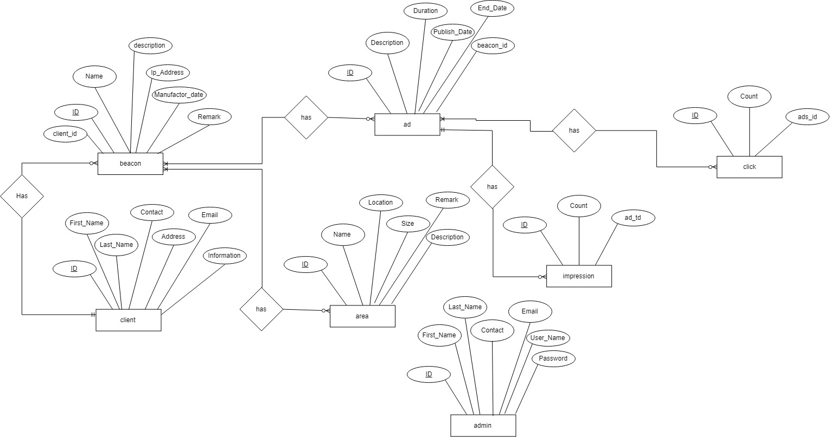

## Schema diagram

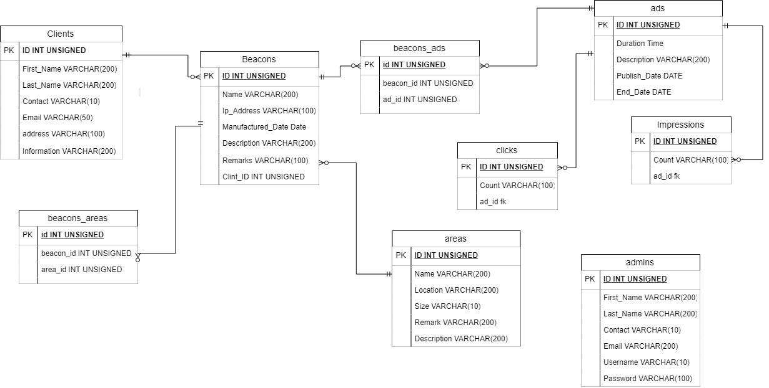

Data dictionary: A data dictionary is a file or collection of documents containing information from a database.The data dictionary includes records of other database items, such as information ownership, information relationships with other items, and other information.

### Data dictionary tables

Beacon

|  |  |  |  |
| --- | --- | --- | --- |
| Attributes | Data type | Length | Constraint |
| ID | int | 10 | Primary key |
| name | varchar | 200 | Not null |
| Ip_Address | varchar | 100 | Not null |
| Manufactured_Date | varchar | 100 | Not null |
| Description | varchar | 200 | Not null |
| Remarks | varchar | 200 | Not null |
| client_id | int | 10 | Foreign key |
| area_id | Int | 10 | Foreign key |

Client

|  |  |  |  |
| --- | --- | --- | --- |
| Attributes | Data type | Length | Constraint |
| ID | int | 10 | Primary key |
| First_name | varchar | 200 | Not null |
| Last_name | varchar | 100 | Not null |
| Contact | varchar | 10 | Not null |
| Email | Varchar | 50 | Not null |
| Address | varchar | 100 | Not null |
| Information | varchar | 20 | Not null |

Admin

|  |  |  |  |
| --- | --- | --- | --- |
| Attributes | Data type | Length | Constraint |
| ID | int | 10 | Primary key |
| First_name | varchar | 200 | Not null |
| Last_name | varchar | 200 | Not null |
| Contact | varchar | 10 | Not null |
| Email | Varchar | 200 | Not null |
| User_name | varchar | 10 | Not null |
| Password | varchar | 100 | Not null |

Ad

|  |  |  |  |
| --- | --- | --- | --- |
| Attributes | Data type | Length | Constraint |
| ID | int | 10 | Primary key |
| Name | varchar | 100 | Not null |
| duration | varchar | 100 | Not null |
| description | varchar | 200 | Not null |
| Publish_Date | date |  | Not null |
| End_Date | date |  | Not null |

Click

|  |  |  |  |
| --- | --- | --- | --- |
| Attributes | Data type | Length | Constraint |
| ID | int | 10 | Primary key |
| Count | varchar | 100 | Not null |
| ad_id | int | 10 | Foreign key |

Impression

|  |  |  |  |
| --- | --- | --- | --- |
| Attributes | Data type | Length | Constraint |
| ID | int | 10 | Primary key |
| Count | varchar | 100 | Not null |
| ad_id | int | 10 | Foreign key |

Area

|  |  |  |  |
| --- | --- | --- | --- |
| Attributes | Data type | Length | Constraint |
| ID | int | 10 | Primary key |
| Name | varchar | 200 | Not null |
| Location | Varchar | 200 | Not null |
| Size | Varchar | 10 | Not null |
| Remark | Varchar | 200 | Not null |
| Description | varchar | 10 | Not null |

Beacon_ad

|  |  |  |  |
| --- | --- | --- | --- |
| Attributes | Data type | Length | Constraint |
| ID | int | 10 | Primary key |
| beacon_id | int | 10 | Foreign key |
| ad_id | int | 10 | Foreign key |

# Part 2

**Once the designs have been accepted by your manager you have been asked to develop the database system using evidence of user interface, output and data validations and querying across multiple tables.**

**You want to include more than just the basics so you will implement a fully functional database system which will include system security and database maintenance features.**

**• You have decided to implement a query language into the relational database system.**

**• The developed system will be demonstrated to your manager.**

**• Your manager has asked you to produce a report including the followings:**

1. **Assessing whether meaningful data has been extracted through the use of query tools to produce appropriate management information.**
2. **Evaluating the effectiveness of the database solution in relation to user and system requirements, and suggest improvements.**

# Introduction

In this part I am going to describe about different data language and I am also creating database, tables. After creating I will include codes used in database system.

# Data definition language

A data definition language  (DDL) is a computer language used in a database to create and modify the structure of database objects. These database include views, schemes, tables, indexes, etc.

CREATE: This command builds a new table and has a predefined syntax. The CREATE statement syntax is CREATE TABLE [table name] ([column definitions]) [table parameters]. CREATE TABLE Employee (Employee Id INTEGER PRIMARY KEY, First name CHAR (50) NULL, Last name CHAR (75) NOT NULL).

ALTER: An alter command modifies an existing database table. This command can add up additional column, drop existing columns and even change the data type of columns involved in a database table. An alter command syntax is ALTER object type object name parameters. ALTER TABLE Employee ADD DOB Date.

DROP: A drop command deletes a table, index or view. Drop statement syntax is DROP object type object name. DROP TABLE Employee.

# Data manipulation language

A data manipulation language (DML) is a family of computer languages including commands permitting users to manipulate data in a database. This manipulation involves inserting data into database tables, retrieving existing data, deleting data from existing tables and modifying existing data. DML is mostly incorporated in SQL databases.

SELECT: This command is used to retrieve rows from a table. The syntax is SELECT [column name(s)] from [table name] where [conditions]. SELECT is the most widely used DML command in SQL.

UPDATE: This command modifies data of one or more records. An update command syntax is UPDATE [table name] SET [column name = value] where [condition].

INSERT: This command adds one or more records to a database table. The insert command syntax is INSERT INTO [table name] [column(s)] VALUES [value(s)].

DELETE: This command removes one or more records from a table according to specified conditions. Delete command syntax is DELETE FROM [table name] where [condition].

# Data Control Language

A data control language (DCL) is a syntax similar to a computer programming language used to control access to data stored in a database (Authorization). In particular, it is a component of Structured Query Language (SQL).

Examples of DCL commands include:

GRANT to allow specified users to perform specified tasks.

REVOKE it is remove the user accessibility to database object.

# Transaction Control Language

Transaction Control Language (TCL) commands are used in the database to manage transactions. These are used by DML statements to handle modifications made to the information in a table. It also allows the grouping of statements into logical transactions.

**Commit command**

COMMIT command is used to store any transaction in the database permanently. When we use any DML command like INSERT, UPDATE or DELETE, the changes made by these commands are not permanent, until the current session is closed, the changes made by these commands can be rolled back. To avoid that, we use the COMMIT command to mark the changes as permanent.

Syntax:

COMMIT;

**ROLLBACK command**

This command restores the database to last committed state. It is also used with SAVEPOINT command to jump to a save point in an ongoing transaction. If we have used the UPDATE command to make some changes into the database, and realize that those changes were not required, then we can use the ROLLBACK command to rollback those changes, if they were not committed using the COMMIT command.

Syntax:

ROLLBACK TO savepoint_name;

# Constraints

Constraints impose data limitations or data type that can be inserted / updated / deleted from a table. The entire aim of the constraints is to keep the integrity of the information during a table update / delete / insert.

Types of constraints

1. NOT NULL:

NOT NULL constraint makes sure that a column does not hold NULL value. When we don’t provide value for a particular column while inserting a record into a table, it takes NULL value by default. By specifying NULL constraint, we can be sure that a particular column(s) cannot have NULL values.

1. CHECK :

This constraint is used to specify the value range for a specific table column. When setting this constraint on a column, the specified column must have the value falling within the specified range.

1. Key Constraints – PRIMARY KEY, FOREIGN KEY

The primary key identifies individual records in a table uniquely. It must have unique values and it must not contain nulls. The field ROLL NO is marked as the primary key in the example below, which means that the field ROLL NO can not have duplicate and null values.

Foreign keys are the table columns pointing to another table's primary key. They act as a tables cross-reference. Read more here about it.

# Joins

Joins can be defined simply as combining or merging the related tuples into a single type from the two different relations. It can be said that it is comparable to cartesian product except that we get all possible combinations of connections in cartesian product while only those combinations that satisfy some corresponding circumstances can be created in joining. Types of joins are:

**Left joins**

All left table datatypes are presented regardless of whether the corresponding requirements are met. Thus all the datatypes were displayed on the left, but on the right only those that meet the matching conditions are present.

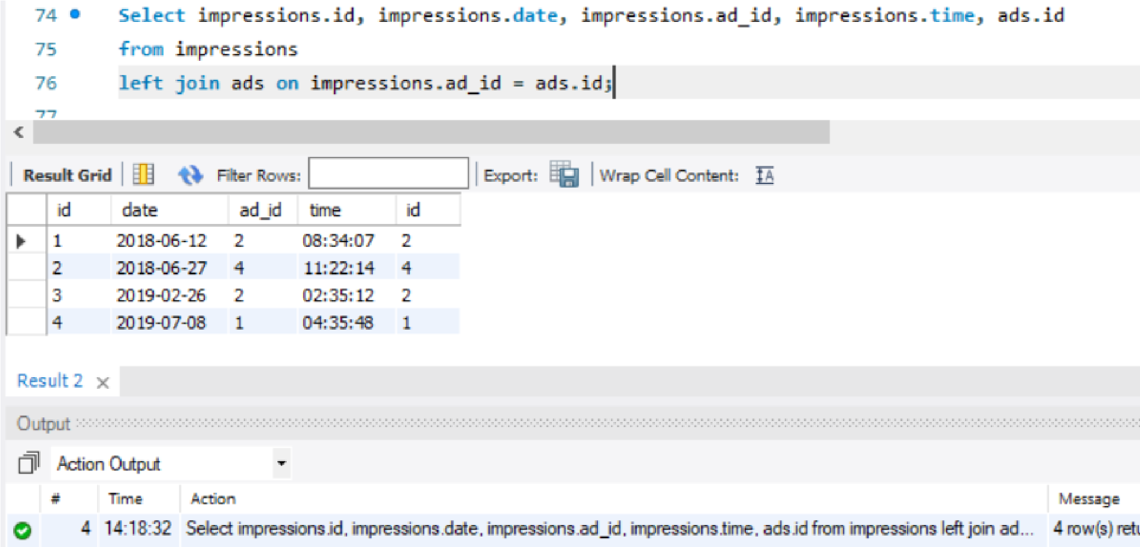

**Right joins**

All right table datatypes are presented regardless of whether the corresponding requirements are met. Thus all the datatypes were displayed on the right, but on the left only those that meet the matching conditions are present.

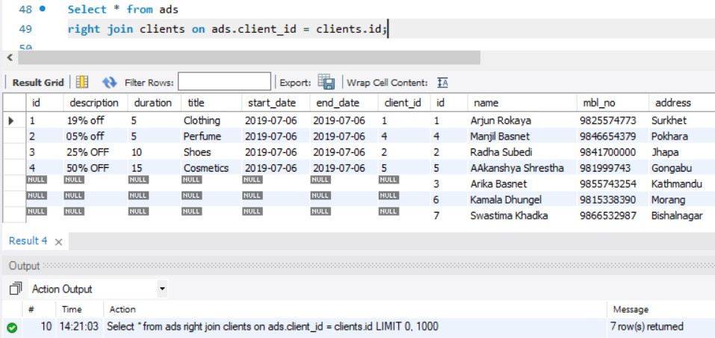

# Development of beacon management system

## Login page

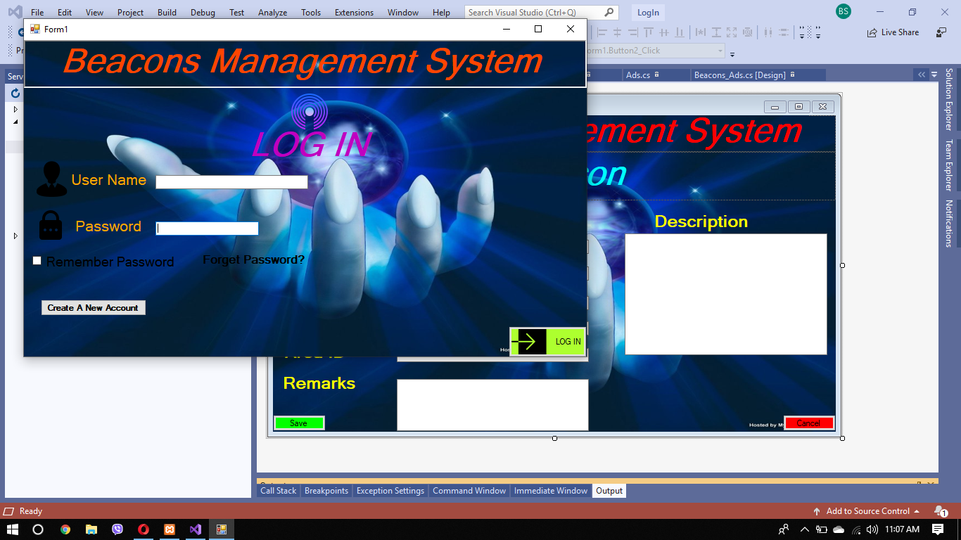

For login

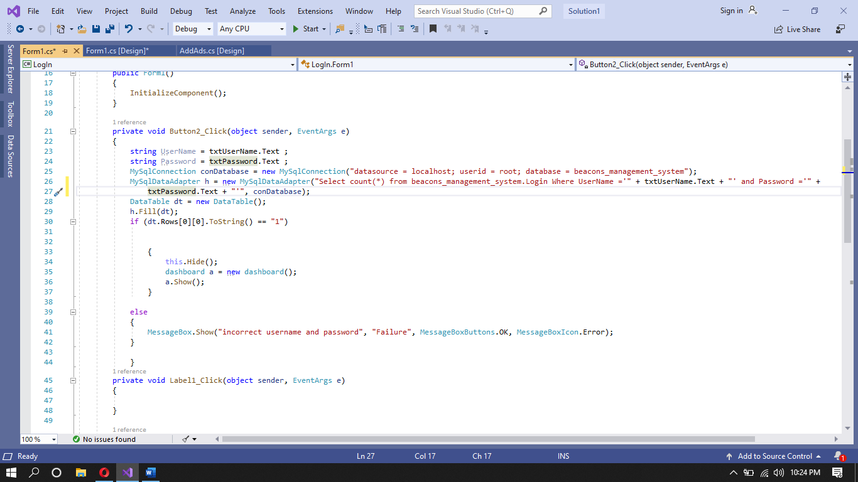

## Dashboard

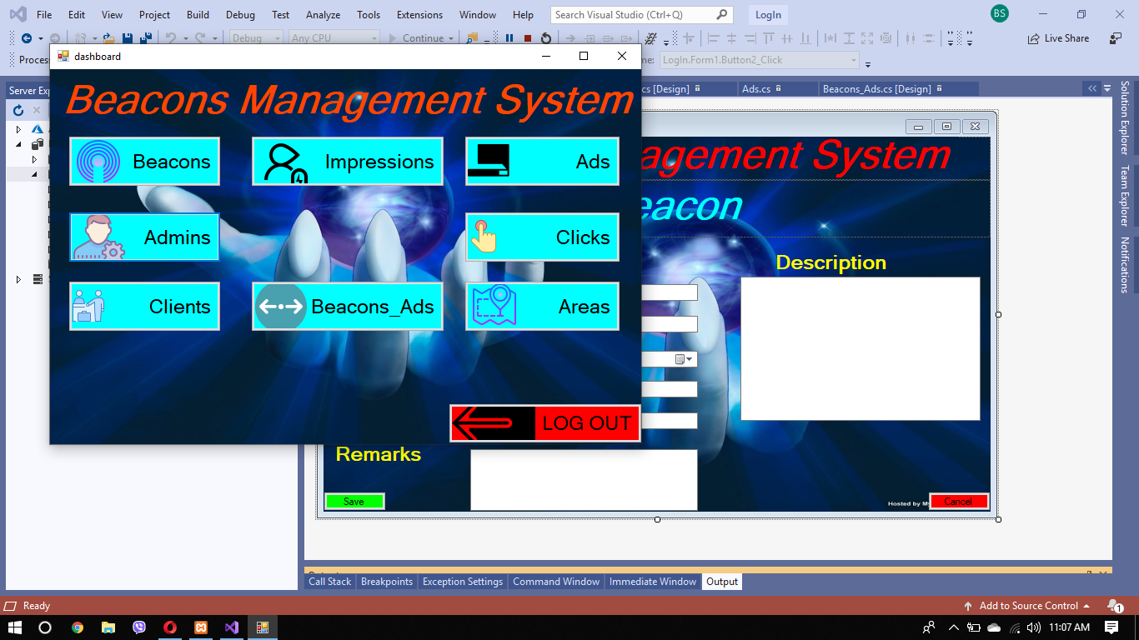

## Beacons

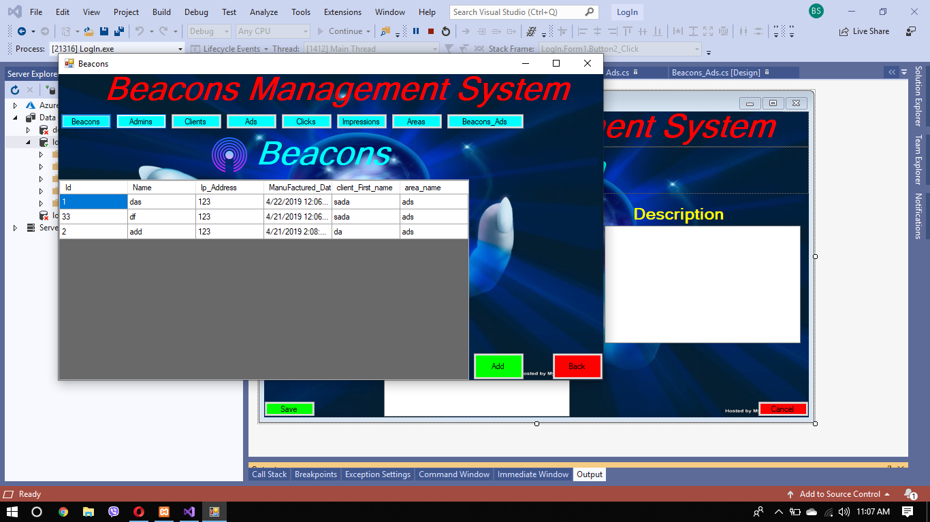

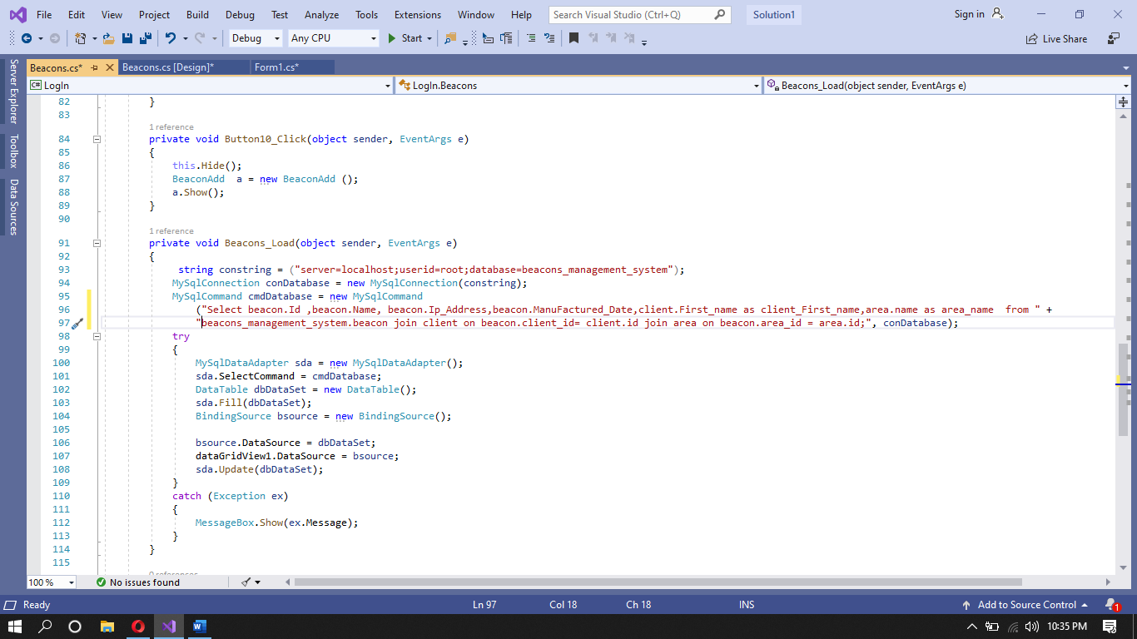Beacon loading

## Add beacon

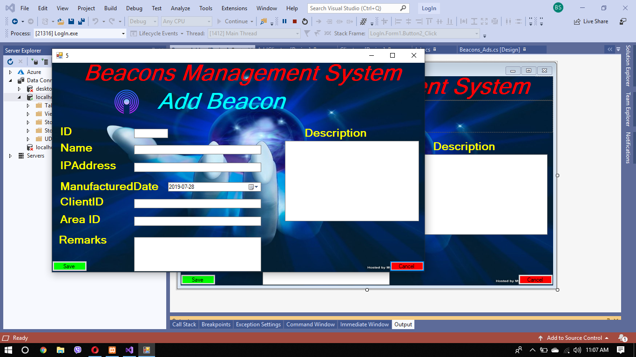

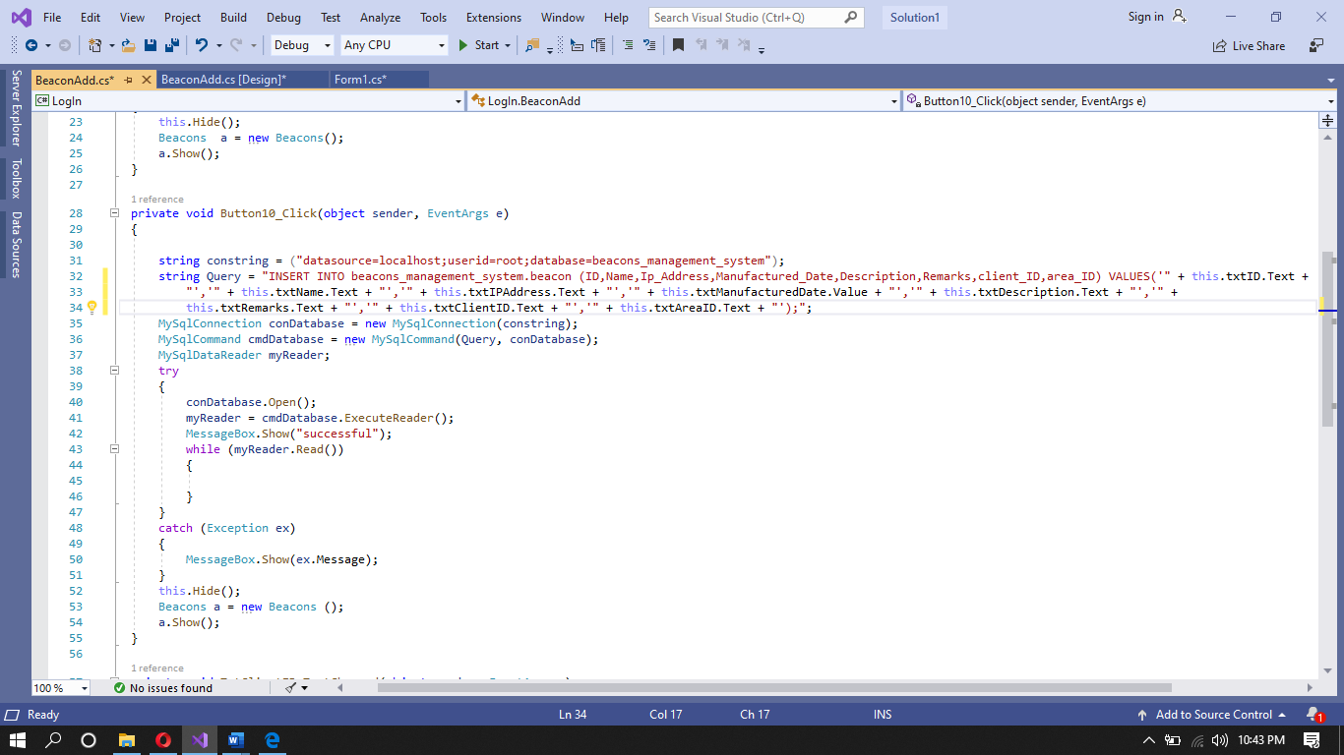

## admins

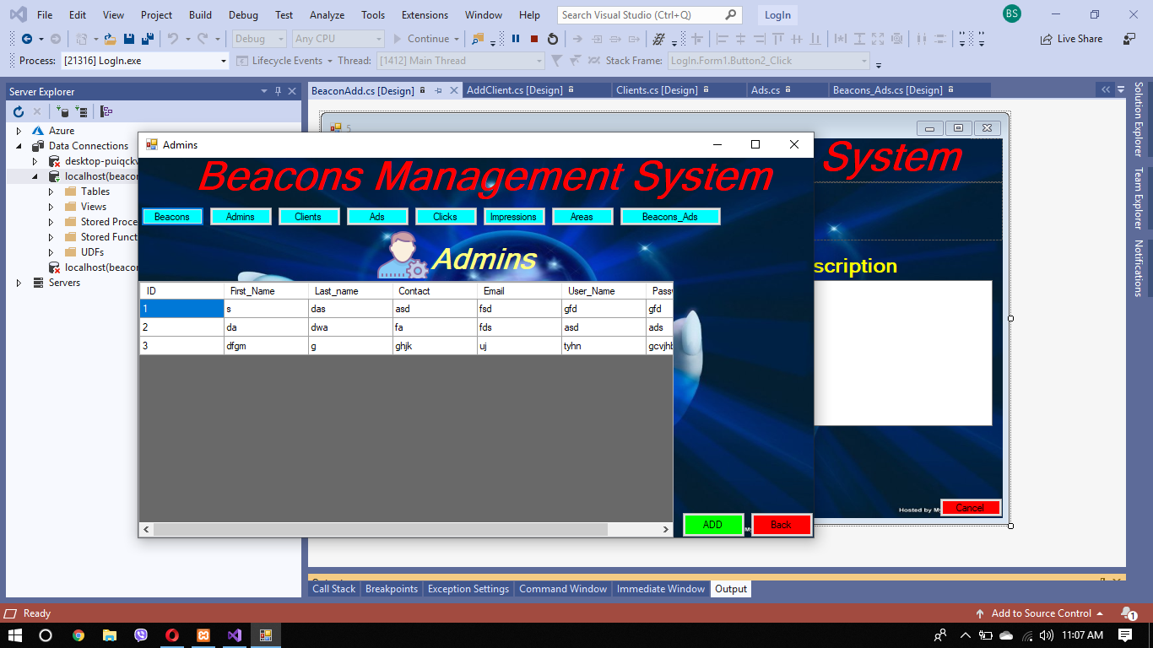

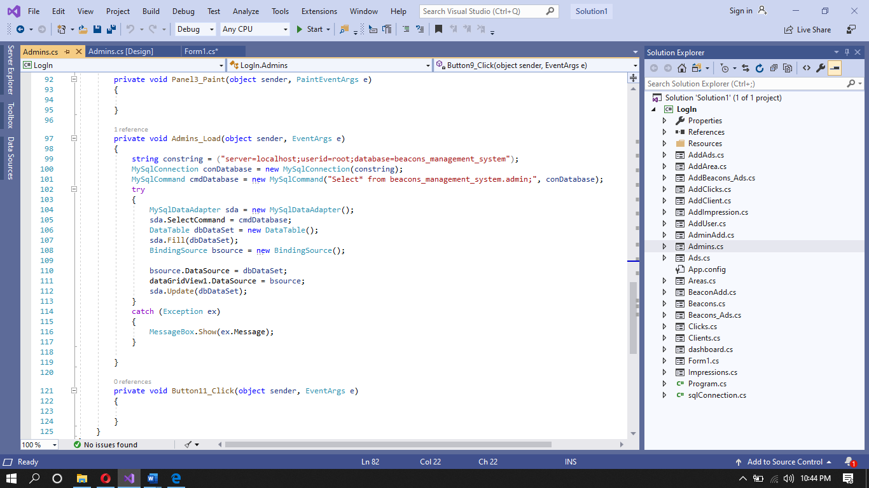

## Add admin

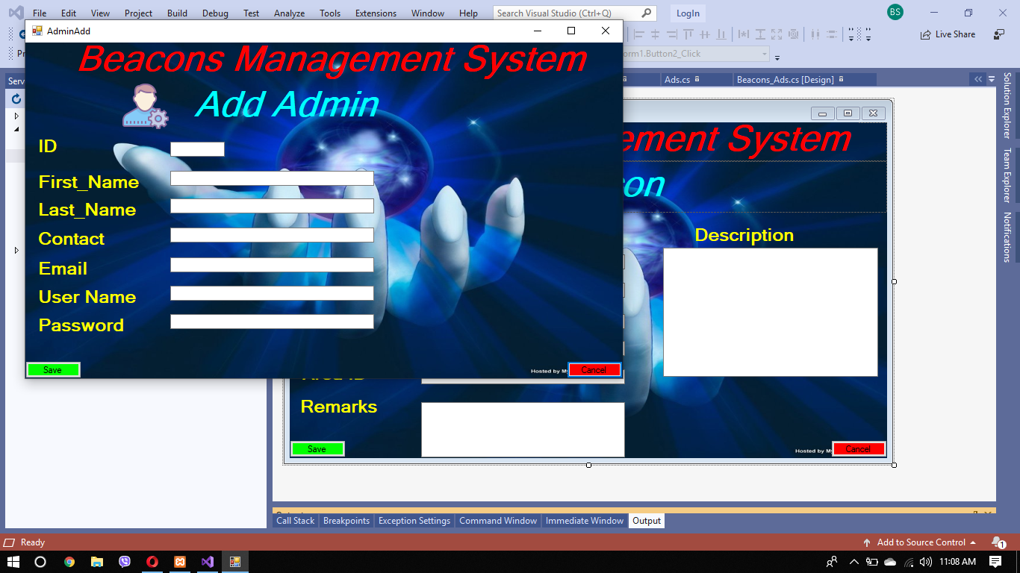

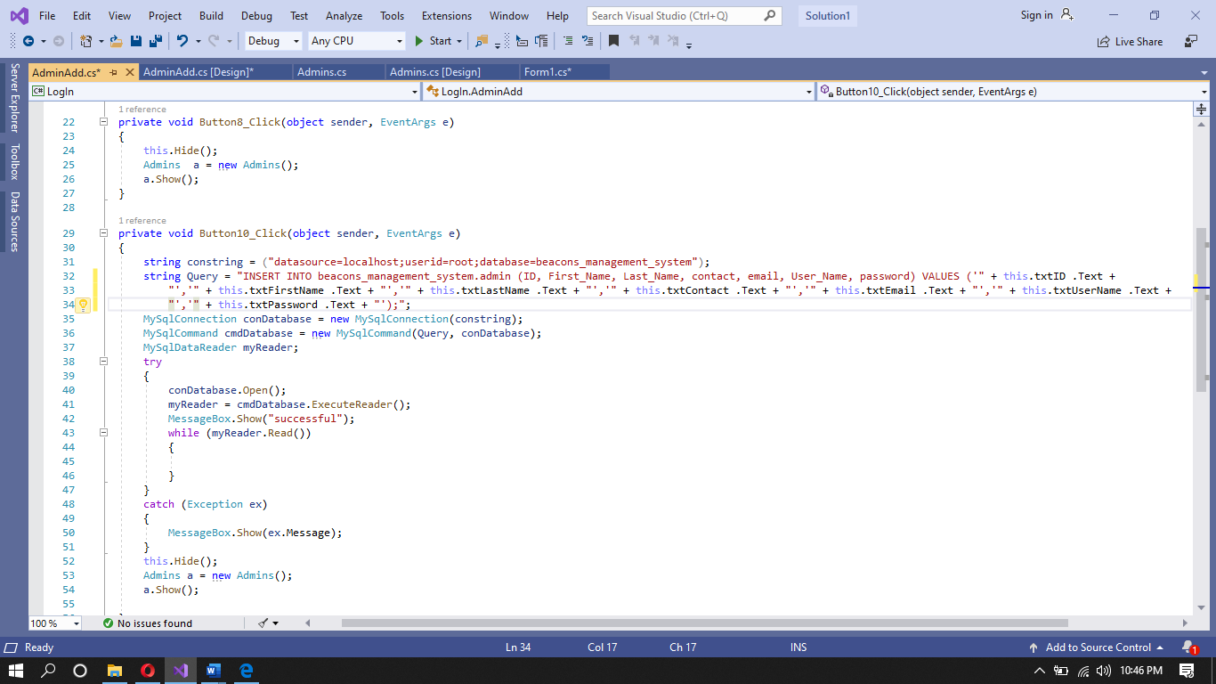

## Client

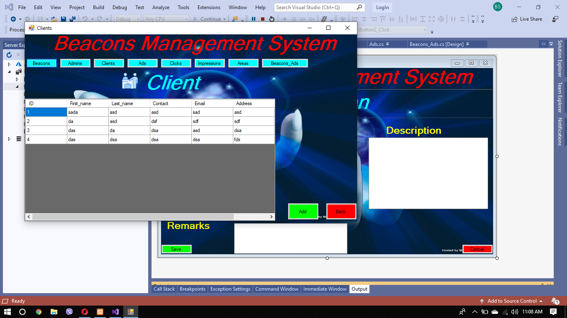

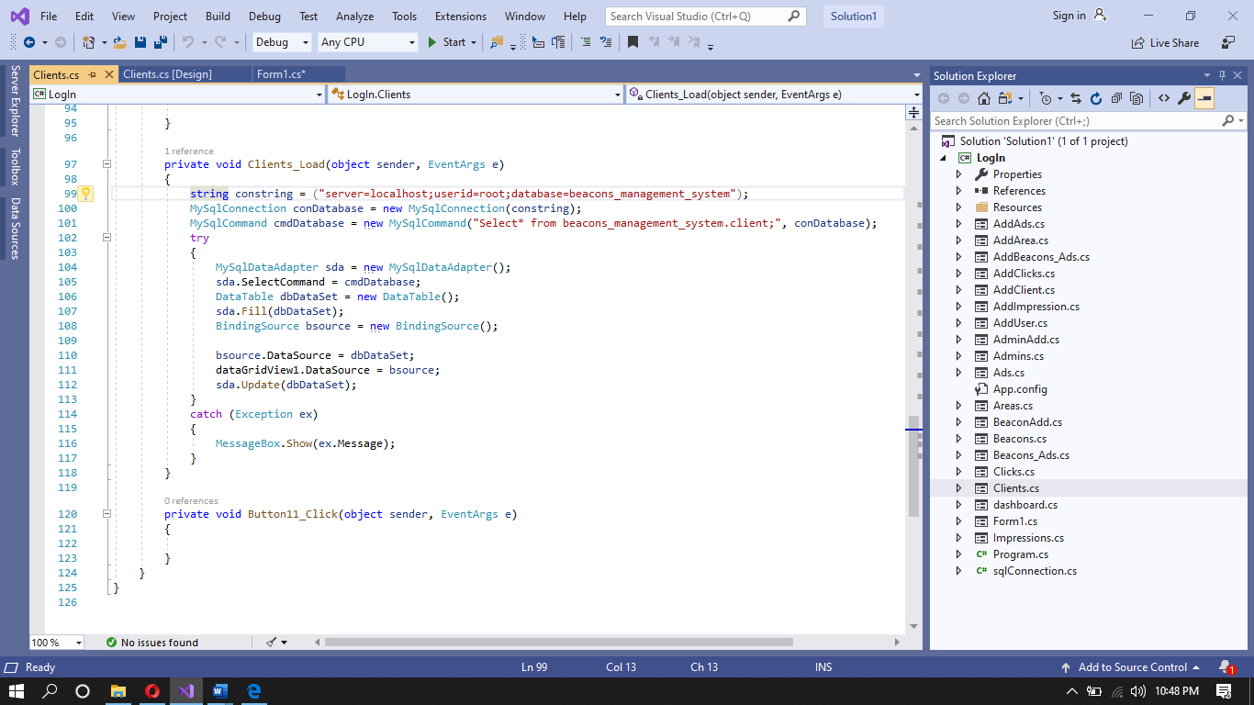

## Add client

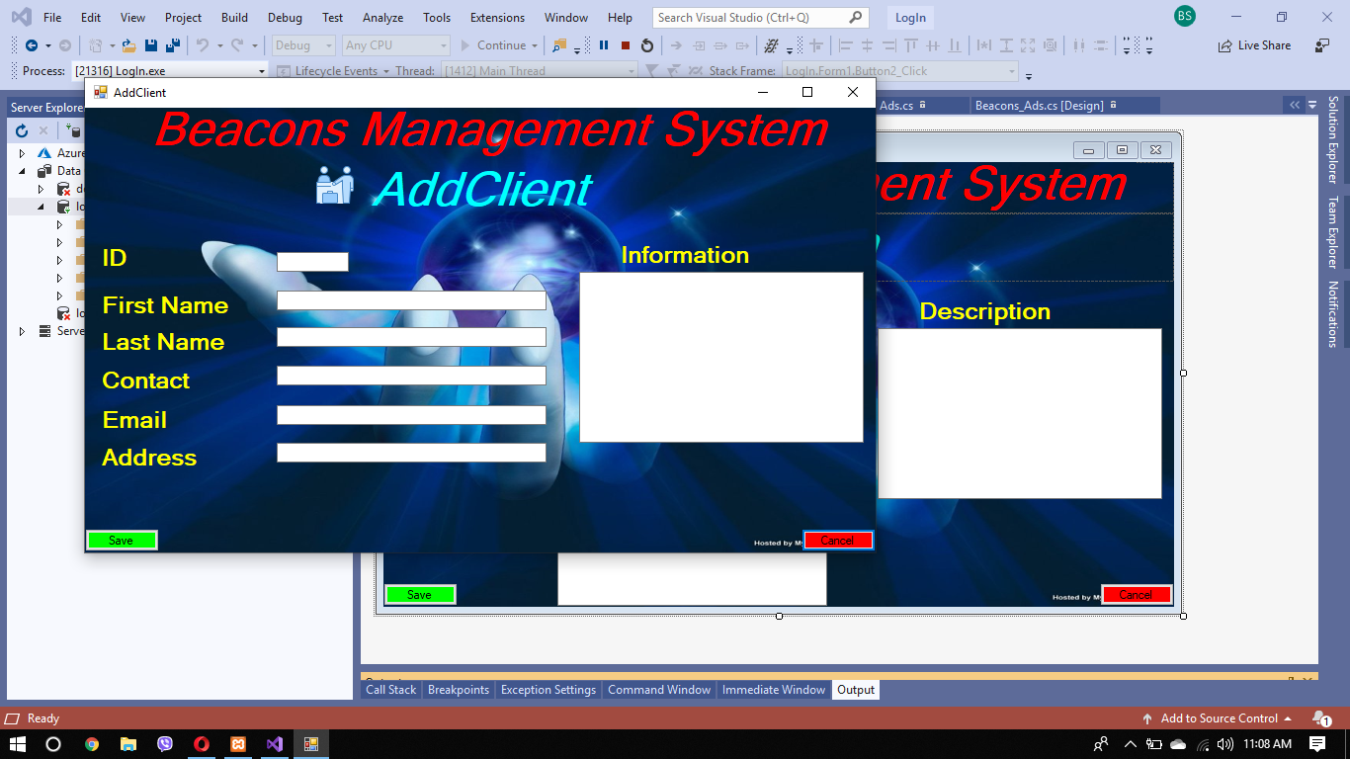

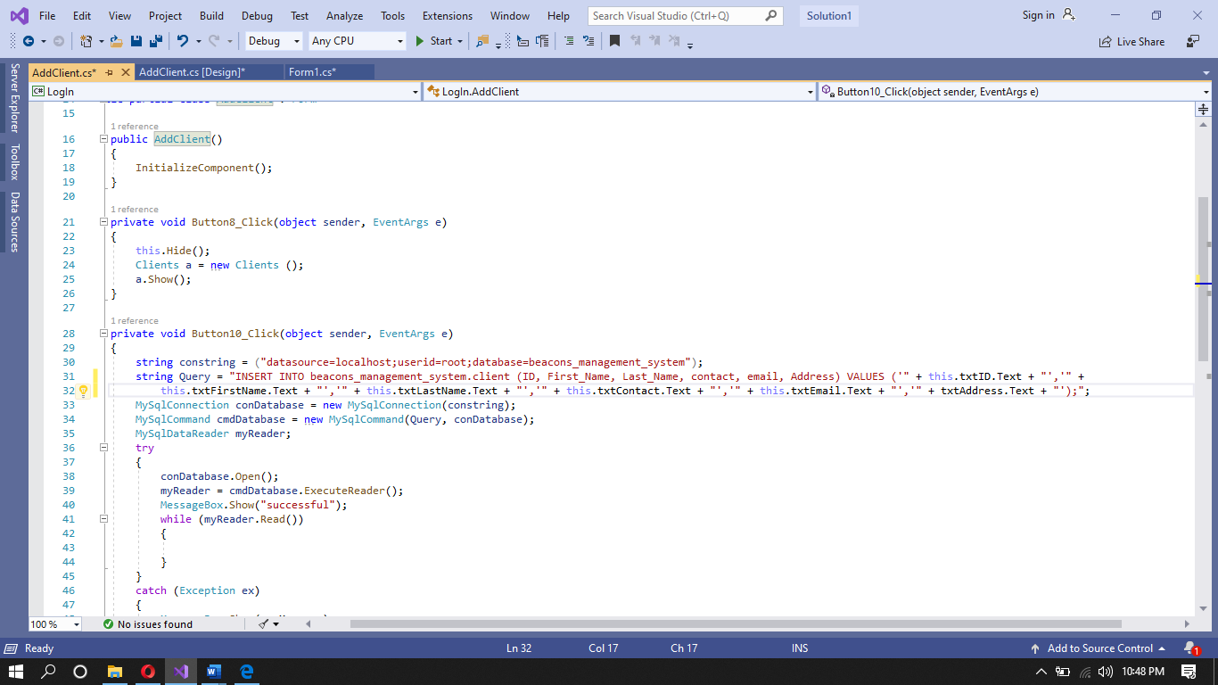

* 1. Ads

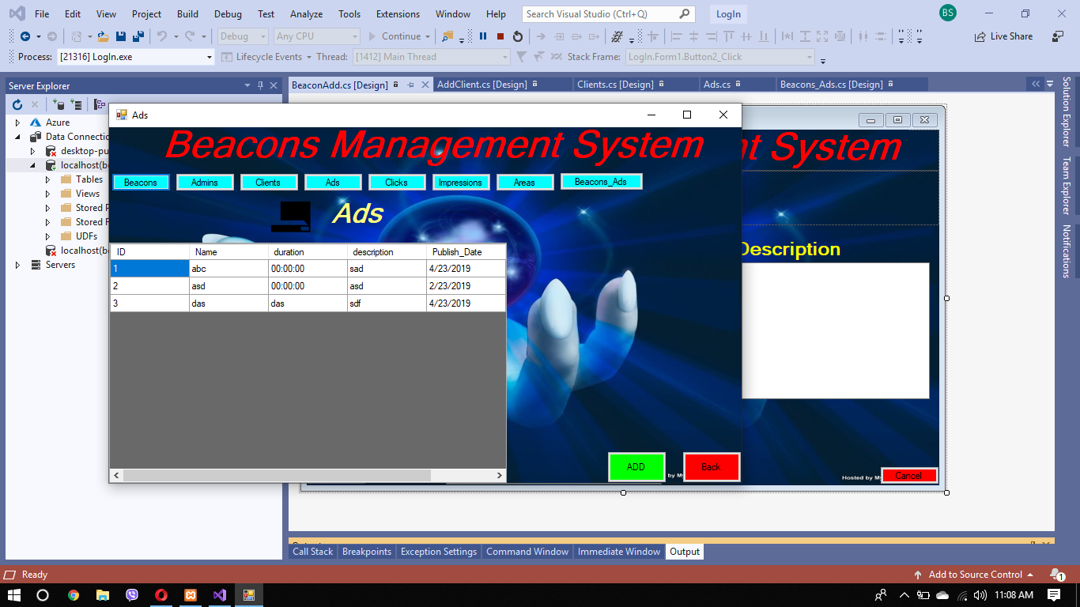

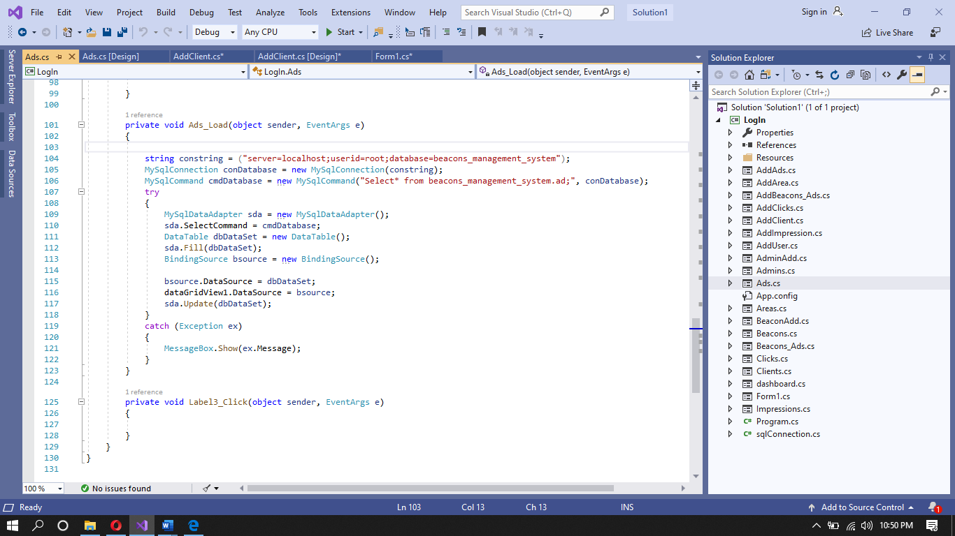

## Add ads

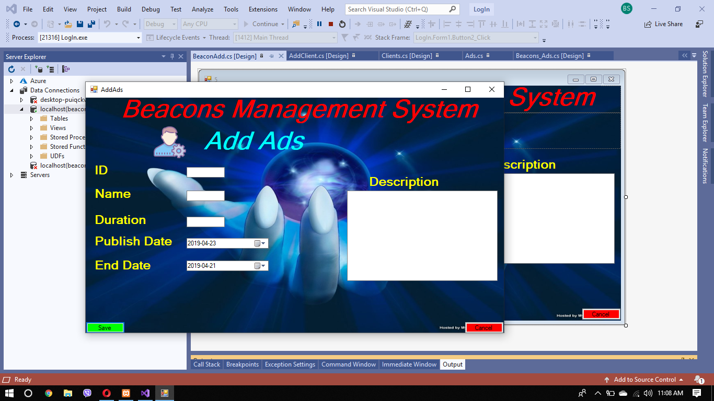

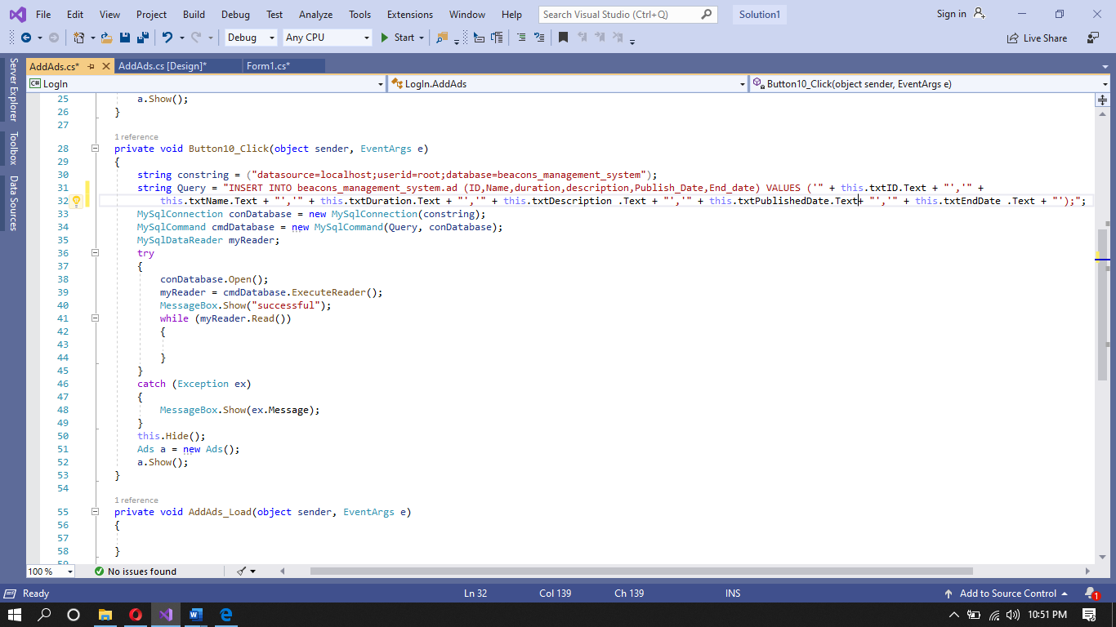

## Clicks

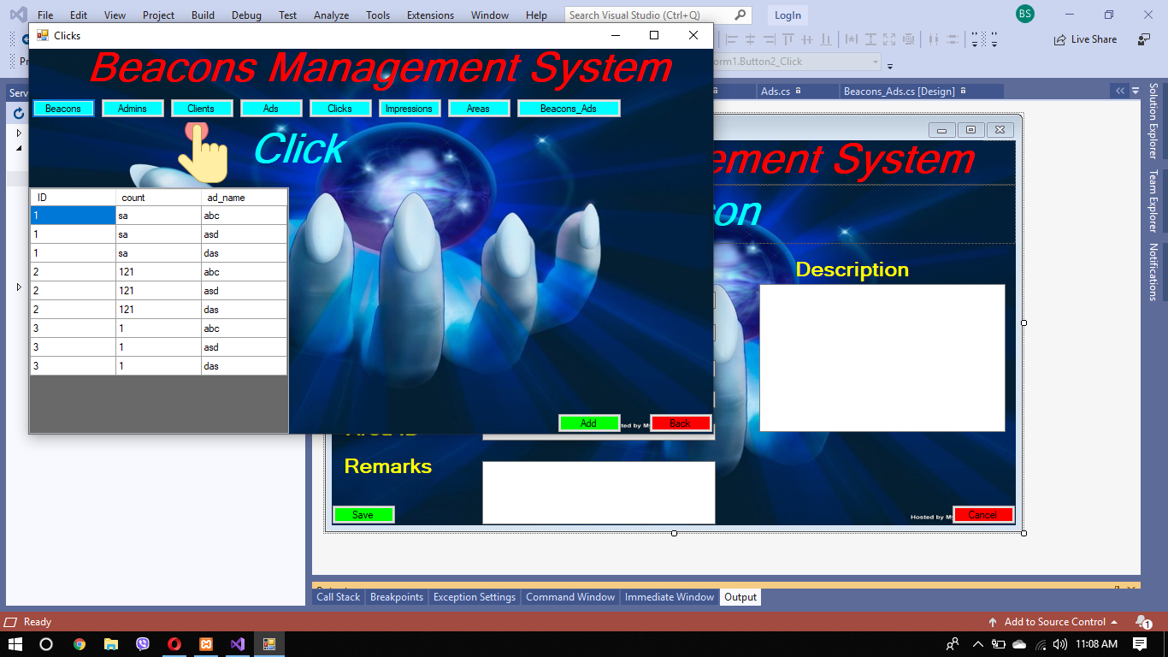

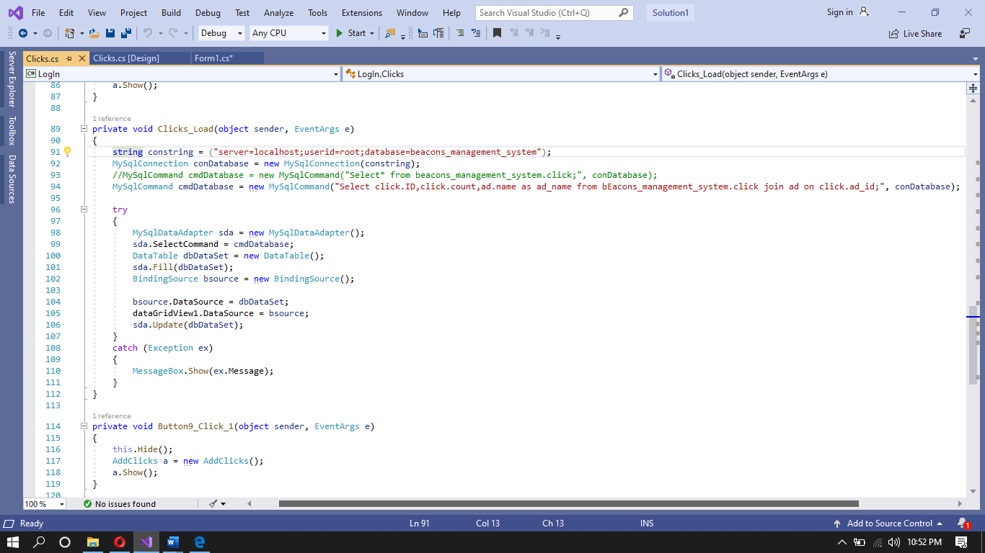

## Add clicks

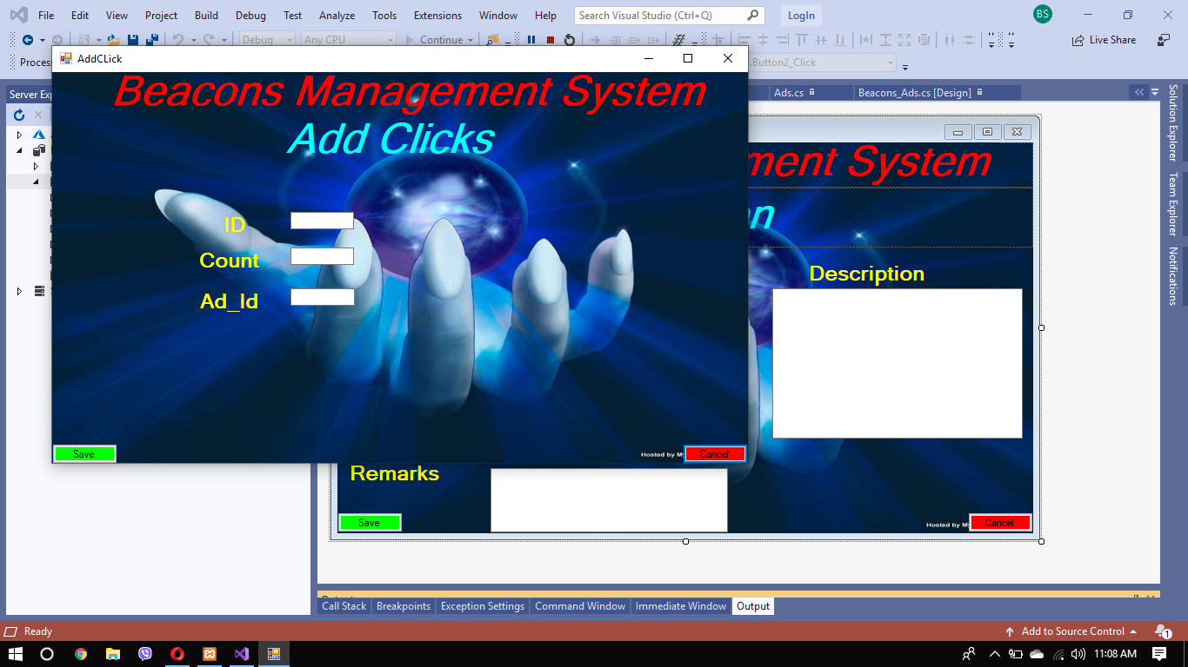

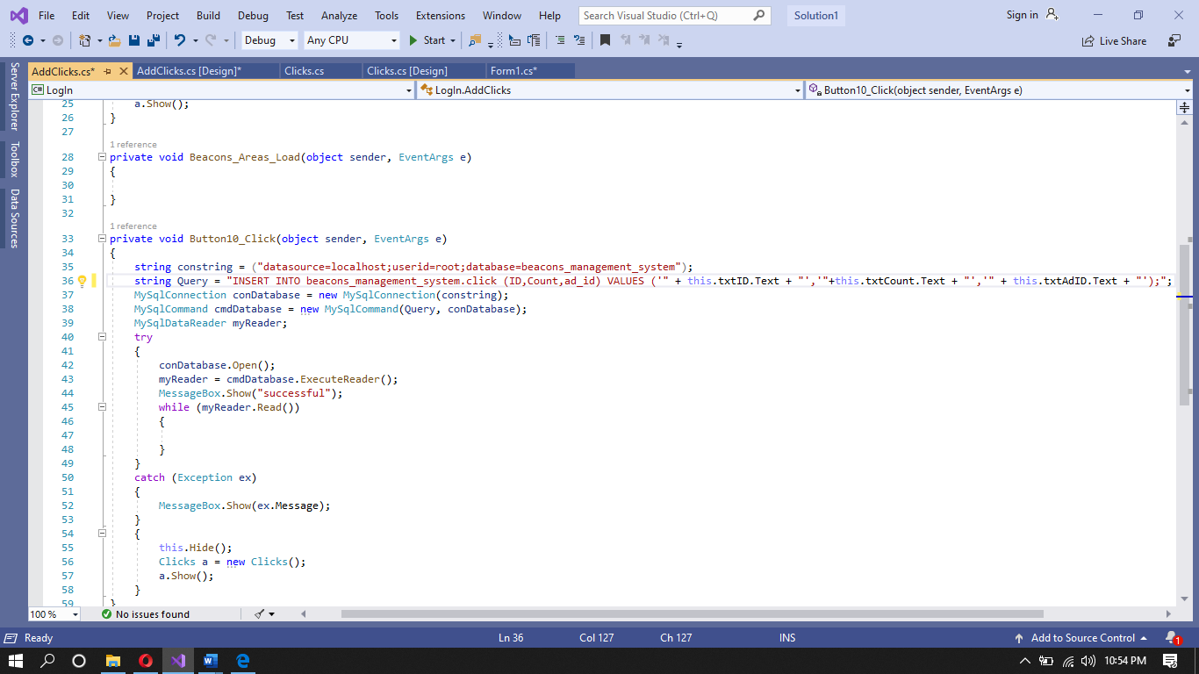

## Impression

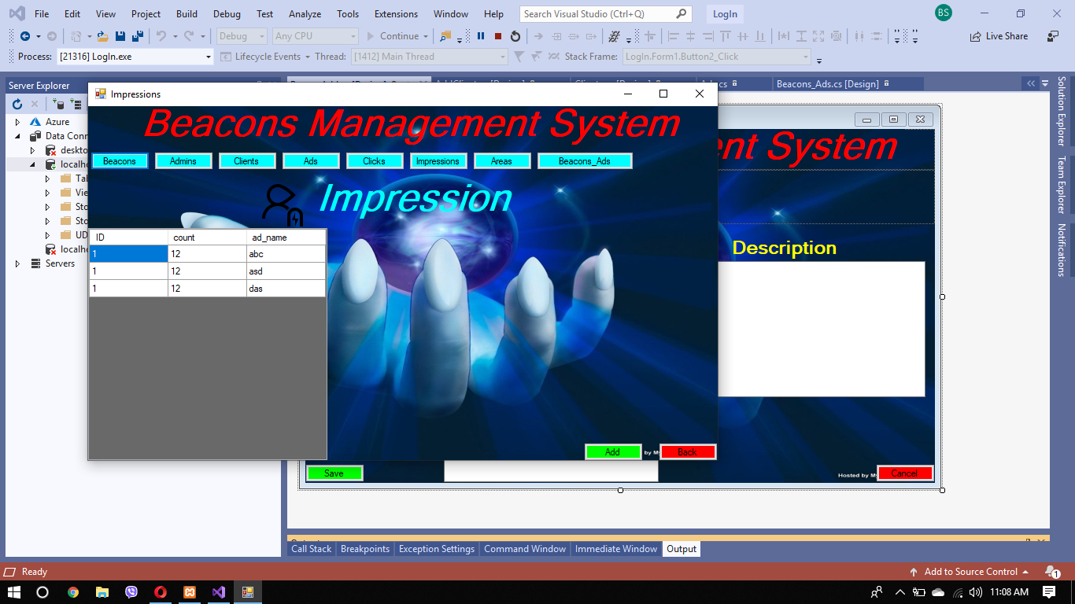

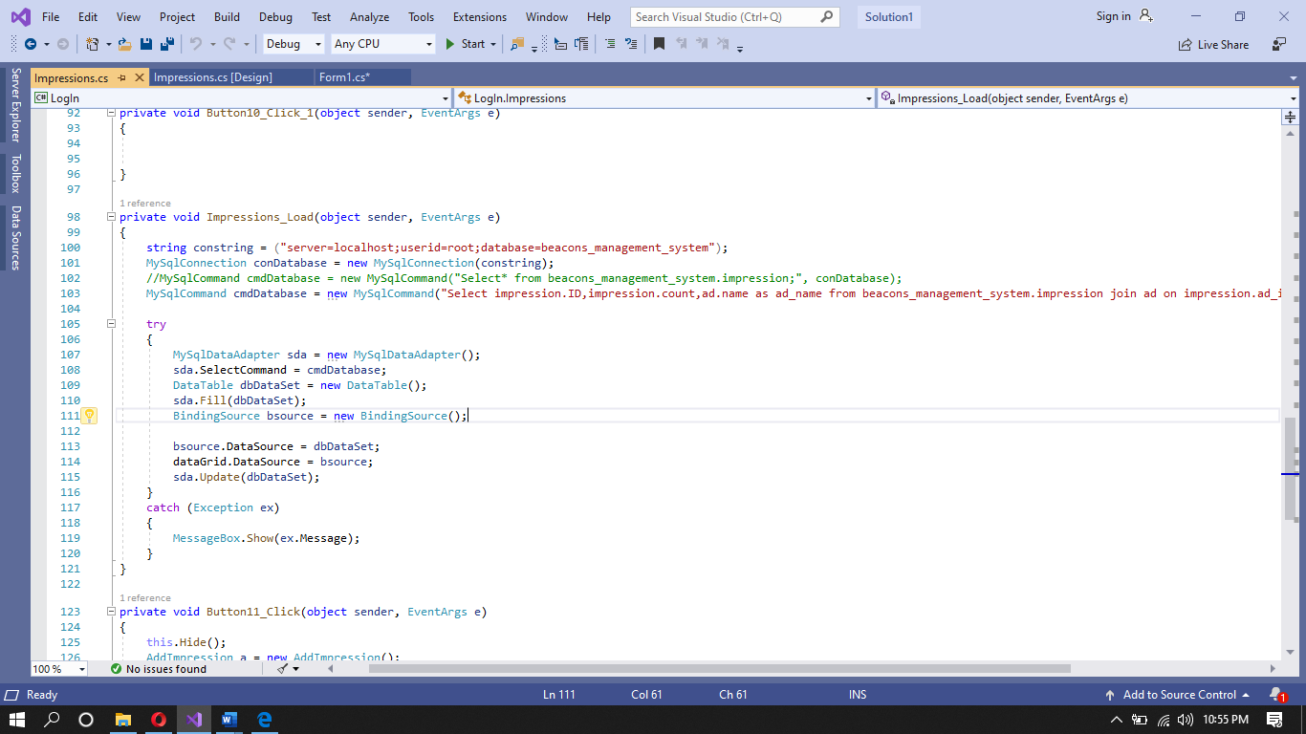

## Add impression

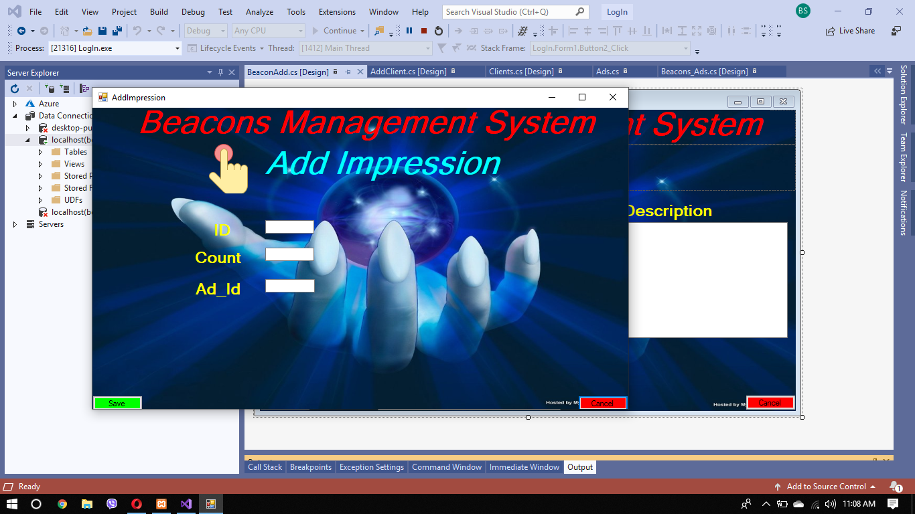

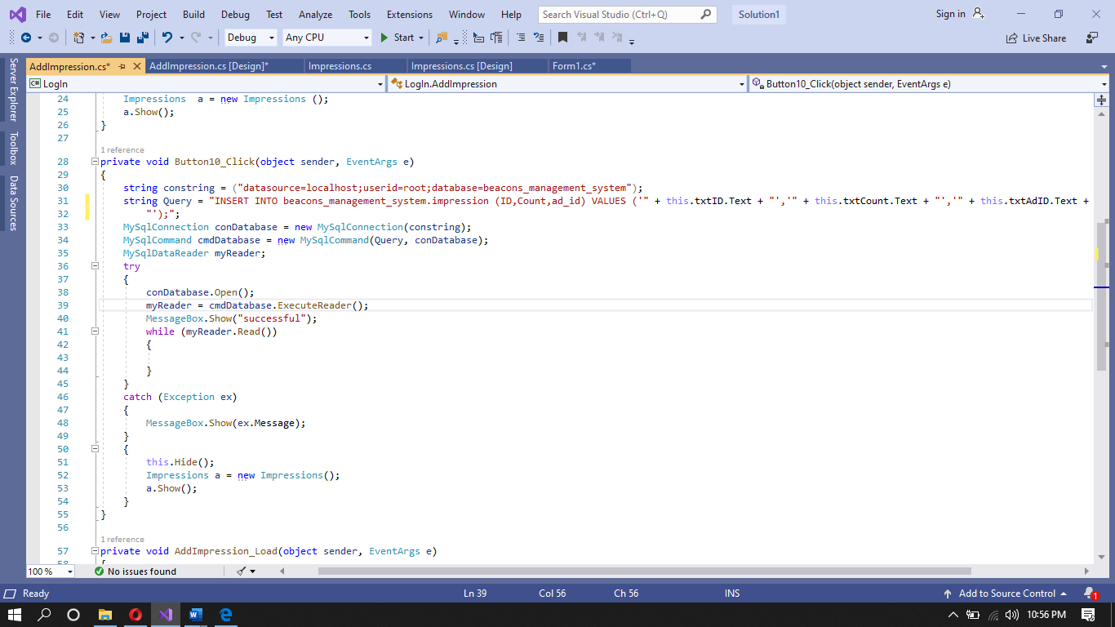

## Areas

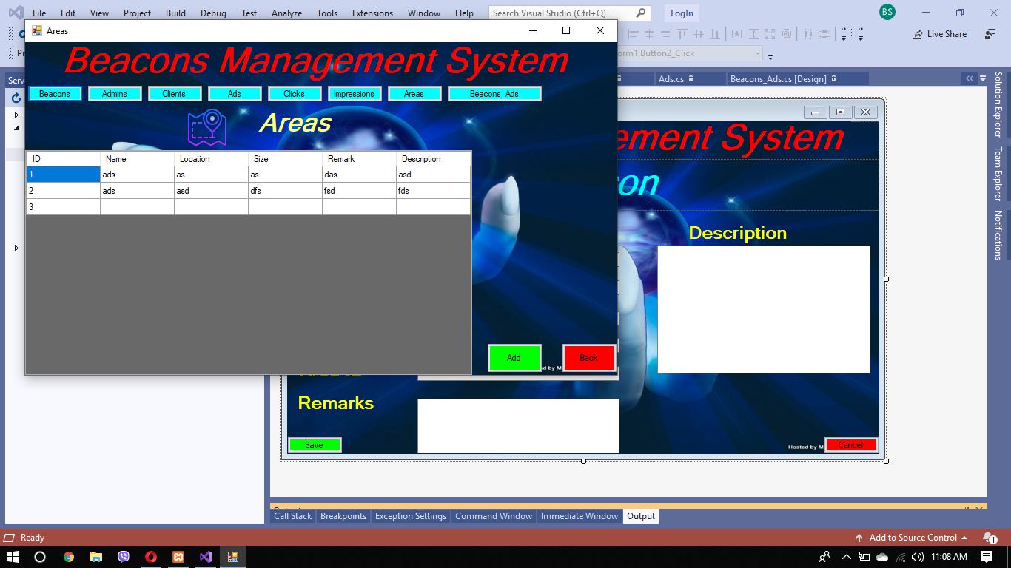

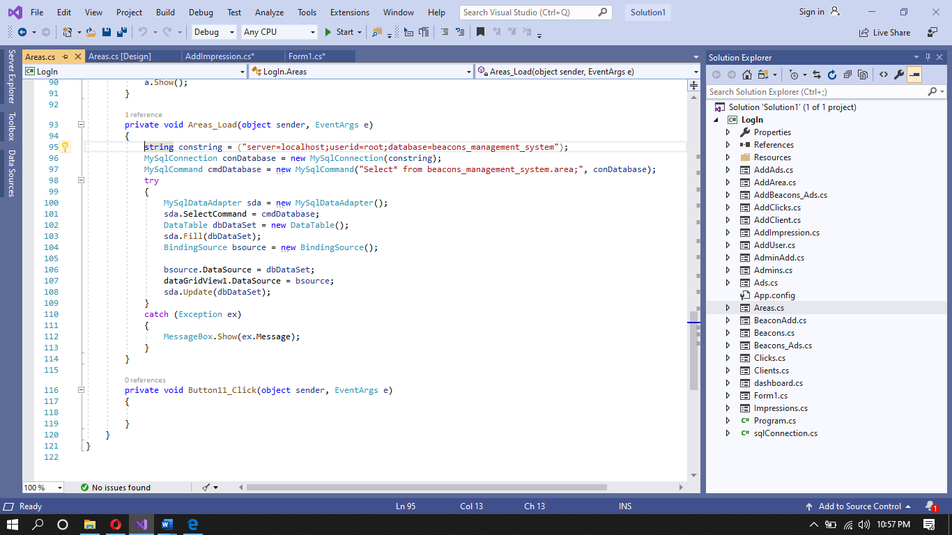

## Add areas

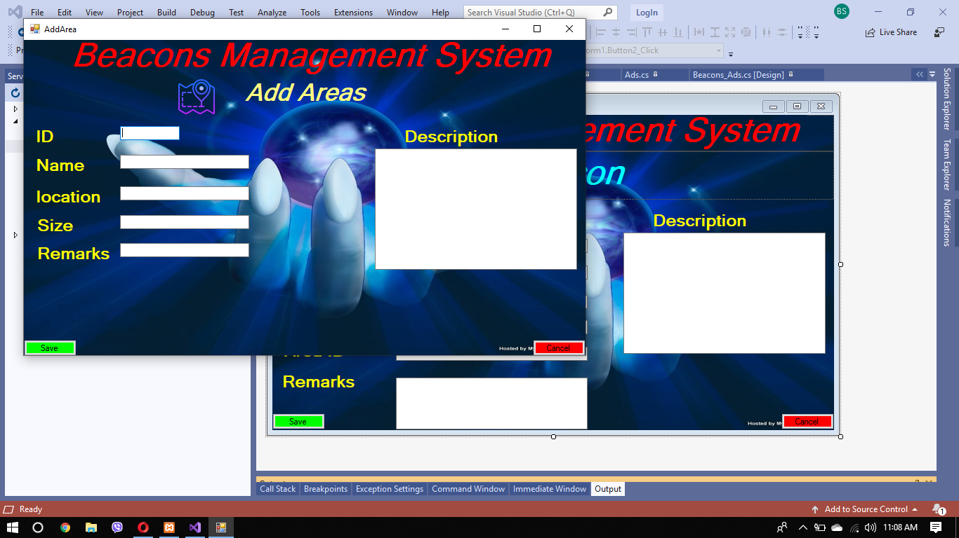

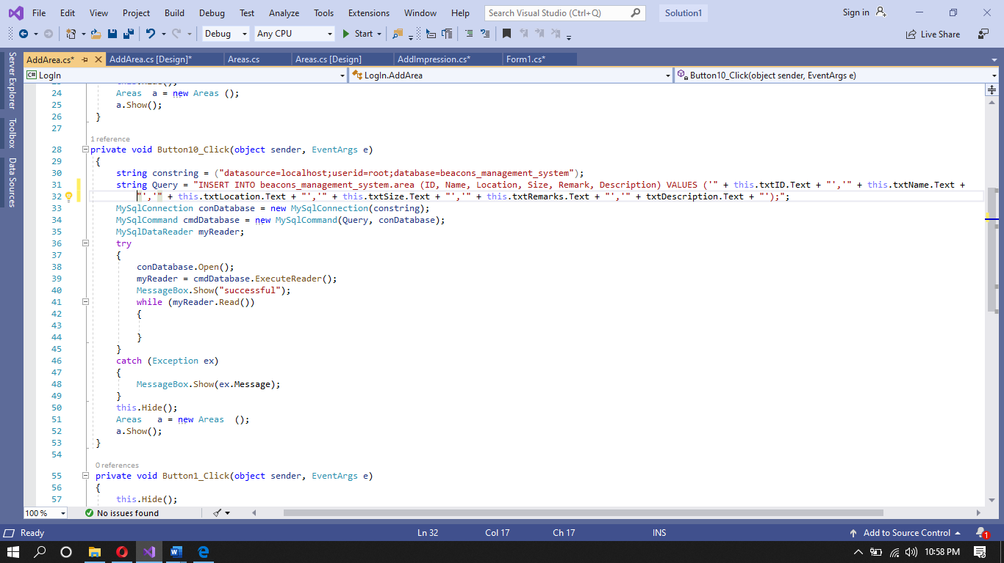

## Beacon_ad

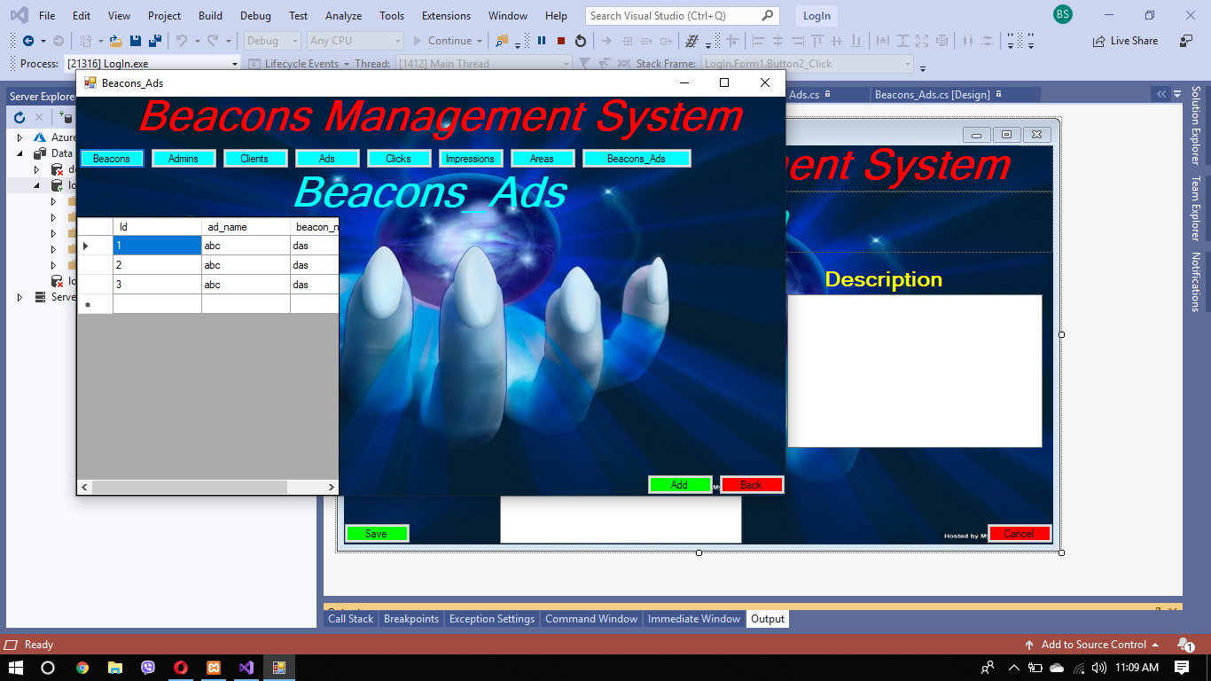

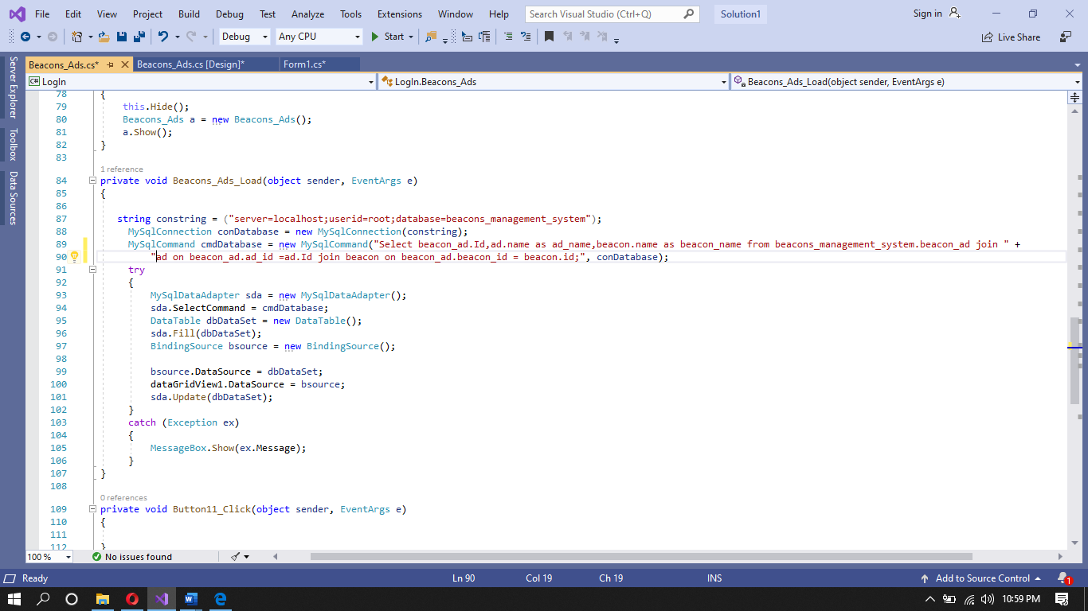

## Add Beacon_ad

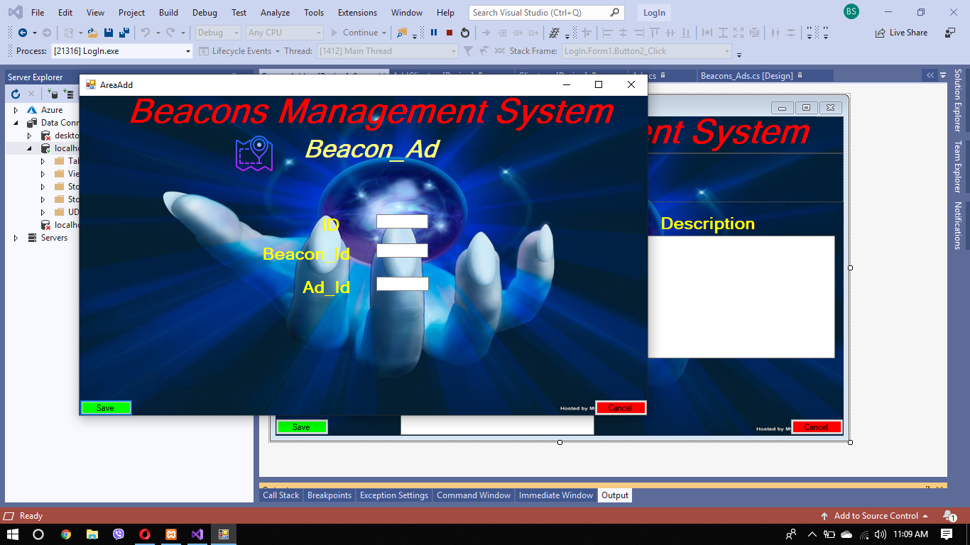

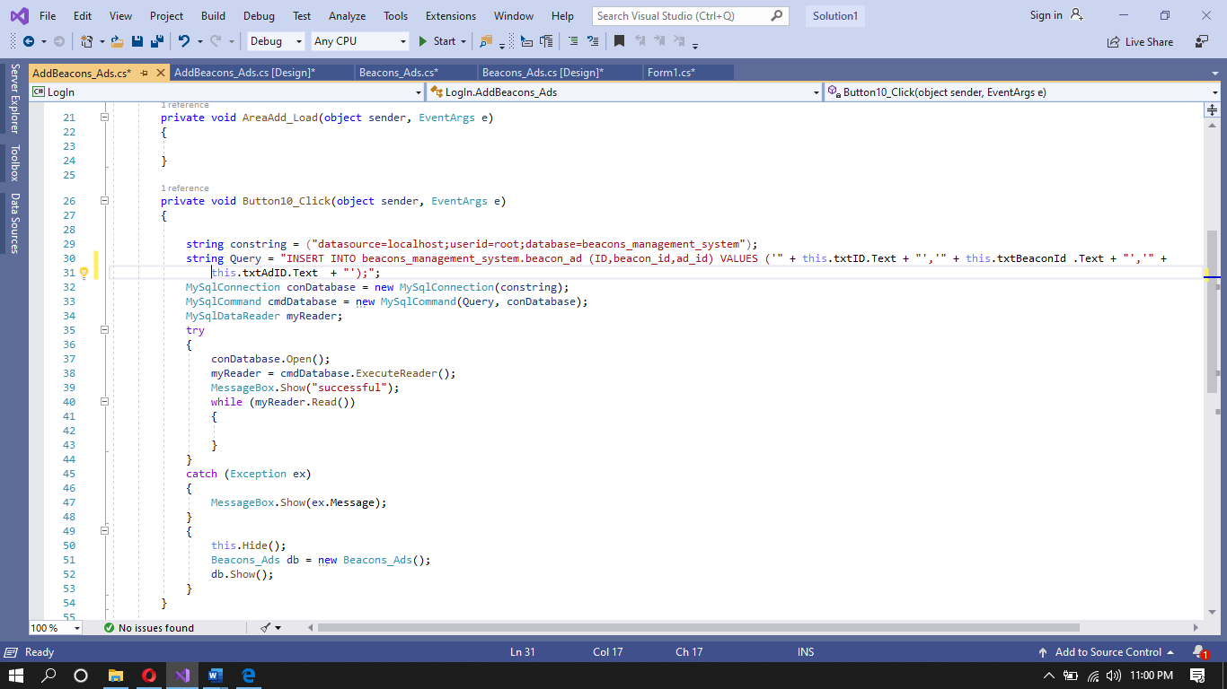

## Conclusion

Constraints are used to minimize the errors by limiting the data entry within its boundary. After testing of the application, it is concluded that there is no problem either in user interface or in the source code. The application is running smoothly with protection from SQL injection. All the data is checked if it is validated or not. Data is maintained through the use of data backup for possible future error or defects handling.

# Part 3

**Test the system against user and system requirements. Produce technical and user documentation.**

**• Once the system has been developed, you will test the system and your manager will complete a witness statement indicating how your tests are performing against user and system requirements.**

**• You will produce a brief report assessing the effectiveness of the testing, including an explanation of the choice of test data used.**

**• Lastly you will produce technical and user documentation which will be given to the company.**

**• You want to provide some graphical representations for ease of reference in the technical guide, so you have decided to produce a technical and user documentation for a fully functional system, including diagrams showing movement of data through the system, and flowcharts describing how the system works.**

# Introduction

Testing is the method of analyzing the report and getting known about the imperfections. It has very much significance for getting over almost the issues. “Database testing refers to the checking schema, tables, columns, keys and indexes, triggers and validating data duplication of the database beneath test which involves making queries to test the database and check its responsiveness”. It is very much crucial to induce known about the database testing in order to keep up with the database and guaranteeing security with quality.

In this task, I have tested the application and the code or, query used in this application. Moreover I would mention the data dictionary of Beacons Management System. I would clarify the project plan whereas designing the application as well as I would show the algorithm and flowchart for the application.

**Database Testing Validations:**

The verifications that are carried out during database testing are:

1. Data mapping:

It is basically utilized for verification of unmapped tables, views and colums. It also functions to merge different databases in to a single database.

1. ACID properties validation:

Each transaction of a database perform has got to follow the four properties which are Atomicity, Consistency, Isolation, and Durability.

1. Data Integrity:

Data integrity is generally used for checking data in each place to check if it is reliably the same.

1. Business rule conformity:

Data integrity is generally used for checking data in each place to check if it is reliably the same.

# Unit testing

Unit testing is a method of software testing that analyzes person software units or components. The aim is to guarantee that each unit of software code works as aiming. Unit testing is carried out by designers during the generation (coding) handle of an application. Unit tests are utilized to isolate a fragment of code to guarantee that it is exact. A unit may be a person work, strategy, method, module, or object.

## Unit testing of Beacons Management System

## **UI Testing**

|  |  |  |  |  |  |
| --- | --- | --- | --- | --- | --- |
| SN | Date | What was tested? | Expected Output | Obtained Output | Was it successful? |
| 1 | 2019/07/11 | Account registering form with less than 8 characters in password field. | Should not create account. | Account was not created with error message. | YES |
| 2 | 2020/03/17 | Account registering form with 8 or, more than 8 characters in password field. | Should create account. | Account was created | Yes |

## **Integration testing**

Integration testing (some of the time called integration and testing, abbreviated I&T) is the stage in program testing in which person software modules are combined and tried as a group. Integration testing is conducted to assess the compliance of a system or component with indicated useful requirements.

|  |  |  |  |  |  |
| --- | --- | --- | --- | --- | --- |
| SN | Date | What was tested? | Expected Output | Obtained Output | Was it successful? |
| 1 | 2019/07/11 | Login form with correct username and password | Should grant access to dashboard. | Granted access todashboard. | YES |
| 2 | 2020/03/17 | Should not grant access to dashboard. | Should not grant access to dashboard. | Access was not granted to dashboard with error message. | Yes |

## **Important of this software Testing**

Using different test methods, determining the quality of the program that was made. A fault-free software is the essential inspiration for presenting hardware experimentation. This is vital since it allows you to recognize errors and correct them some time recently you display before clients. This guarantees that the application's capacities run smoothly and without mistakes. The security of the application is tested, so we don't got to worry around the information spoiler creating vulnerability-free applications.

## **Testing Approach that are used**

### Black-box

Black-box testing includes testing interfacing and the integration of the database, which includes: Mapping of data (counting metadata) ... Confirming active data from query functions. Different methods such as Cause effect graphing method, equivalence partitioning and boundary-value analysis.

|  |  |  |
| --- | --- | --- |
| Sn | Advantages | Disadvantages |
| 1 | Analyzers don't require specialized knowledge, programming or IT abilities | Difficult to automate |
| 2 | Tests can be executed by crowdsourced or outsourced analyzers | Difficult to calculate test coverage |
| 3 | Low chance of untrue positives | In case a test fails, it can be troublesome to understand the root cause of the issue |

### Whitebox testing

The white box testing method mainly deals with the inside structure of a particular database, where the specification details are covered up from the client. ... It chooses the default table values in arrange to check on the database consistency. It checks the rule of Referential Integrity.

|  |  |  |
| --- | --- | --- |
| Sn | Advantages | Disadvantages |
| 1 | Capacity to achieve total code coverage | Requires a large effort to automate |
| 2 | Easy to automate | Sensitive to changes in code base, automation requires expensive maintenance |
| 3 | Sensitive to changes in code base, automation requires expensive maintenance | Cannot test expected functionality that does not exist in the codebase |

**List of expected result and actual result with comments**

|  |  |  |  |  |  |
| --- | --- | --- | --- | --- | --- |
| SN | Date | What was tested? | Expected Output | Obtained Output | Was it successful? |
| 1 | 2019/07/11 | Duplicatio n of primary key. | Query should not be executed and record should not be inserted. | Granted access todashboard. | YES |

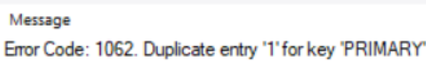

**Choice of data for test operation**

The primary key is the one of a kind key to clearly distinguish the data. A table has only one essential key and it is compulsory to define id. There can be no two columns with the similar primary key.

**Effectiveness of test**

The result after the checking of duplicate primary key is as effective as wanted. For any record, the primary key need to be unique and should not be copied. The above inquiry isn't executed as the ID appears the mistake notice "Copy entry' 1 ' for key' PRIMARY'.' The test guarantees that you can't reproduce the essential key.

# Prerequisite Specifications

There are many expectations and goals that must be tended to by the Beacons Management System. A few requirements were required after a careful examination of the whole system. The old database system had imperfections and limitations that required to be tended to. The new system had to fulfill the following requirements:

* Attractive user interface.
* Advertise wisely.
* Uses it as a database of Microsoft SQL.
* Verification of two steps.
* Two kinds of users should exist.
* Import and import characteristics should be integrated
* Advertising information and more should be provided for publication.

# Areas of Improvement

The above necessity is all well regarded by the developed application. In spite of the fact that there are functions that fulfill the requests, a few characteristics can be presented to extend productivity, security and adaptability in the same software. Following are the improvements which can be done:

* **Performance**

The software's speed of work and the time it takes to run. The time it takes for the software to respond, the user interface, and consistency all contribute to the software's performance. The created program could be a simple system for keeping up or keeping records. It takes no time at all to store the data that was recorded in the program directly within the database. When the most recent characteristics are inserted, it may break down the efficiency of the program. The UI board must be opened in no minute and the reaction time of the applications must be improved to be properly applicable.

* **Scalability**

Since the data can as it were be included, the software run is diminished. This type of little program focuses exclusively on data recording. Additional or special usefulness may be included to the app to improve it. User's responsibility, page loaded and history could be included on the program that makes a difference the software to perform effectively. You'll be able include the different number of demands and hardware to the system that increases the working of the system.

* **Security**

The security features of the Beacons Management System secure and avoid unauthorized entry, threats, and malicious harm. To get to the application dashboard, you must enter the right username and password. To ensure the real title of the database record, a client confirmation method is executed, and opinions are produced, and as it were the proper columns are appeared to the user.In order to maintain data integrity and accuracy, several data validation and safety steps are used. Utilizing two-step checking, the software security might be encourage upgraded. You'll take after the encryption operation to defend the information. You could apply password policy to produce a solid password. It is possible to include timely organized backups to defend data loss.

# Further Enhancement in the application

Different modifications in the model can be made to further improve the software.

* Page loading characteristics.
* Data import and export arrangement.
* The software must be justifiable and take no moment.
* Timely planned backups for data security for further use.
* User code can be encrypted, authenticated and managed to boost safety.
* User and technical records can be improved to assist user to become more comfortable with the software.

# Types of Documentation:

The two types of documentation are discussed below:

* **Technical Documentation:**

Technical documentation refers to any record that explains the utilize, usefulness, creation, or design of a item. Technical documentation isn't just about capturing data. It's about showing it in a way that's simple to read, usable, and really helpful for your audience.

* **User Documentation:**

User documentation refers to the documentation for a item or service given to the conclusion clients. The user documentation is designed to help conclusion clients to utilize the product or benefit. Usually often referred to as user help. The user documentation is a portion of the overall item delivered to the client.

# User manual

## Introduction:

Welcome to the Beacon Management System. It is a recording course of action where you'll be able enroll an information related to beacons and promotions. It is simple to keep and exploit the data carefully. You'll discover user friendly environment here in our application.

## Login Form



It is the first page which is shown after opening the application. The login page appeared within the figure above contains a lot of characteristics. As the light picture is utilized, the layout shows up engaging and is user-friendly. Logging into account is much less demanding for the user. Using textbox, picture box, buttons, names and check box, the frame was planned.

## Registration Form



It is the form planned to enlist a title for the client. In case a client as of now registered their name at that point they will login straightforwardly using the username and password they used whereas registering but in case they haven’t enlisted their name at that point they would press on the create a new account button appeared within the login page. This will open the page. This registration page was made by the utilize of content box, names, buttons and check box.

## Dashboard



Client control showing Home page is the first page to be shown after logging in. It contains the screenshots of a few modules with the preferences and description of the Beacon Management System. This user control is made utilizing picture box, wealthy content box, name and interface name. Its plan is appeared below:

After clicking on the “beacons” button, u can get access to the add beacons list. This user control gives you the information about the beacons. It is created using link label and label. Its design is shown below:

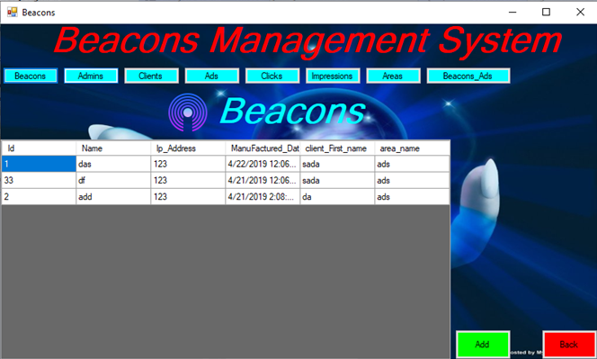

After clicking on the “admin” button, u can get access to the admin list. This user control gives you the information about the admins. It is created using link label and label. Its design is shown below:

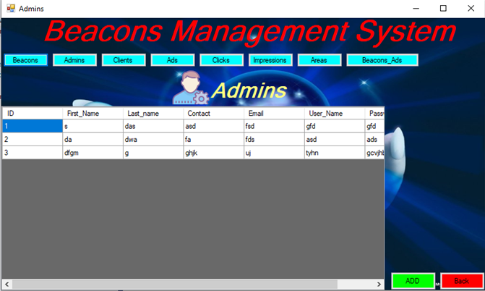

After clicking on the “client” button, u can get access to the client list. This user control gives you the information about the client. It is created using link label and label. Its design is shown below:

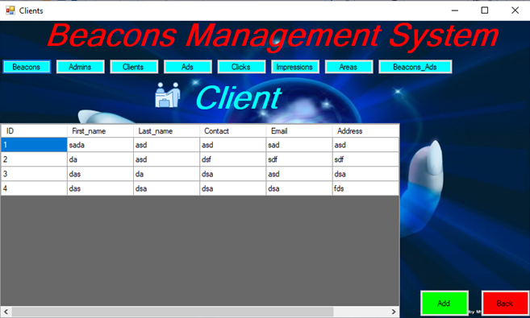

After clicking on the “clicks” button, u can get access to the click list. This user control gives you the information about the click. It is created using link label and label. Its design is shown below: 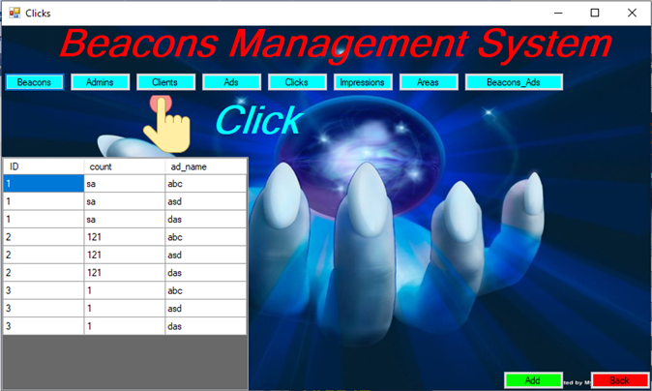

After clicking on the “areas” button, u can get access to the areas list. This user control gives you the information about the areas. It is created using link label and label. Its design is shown below: 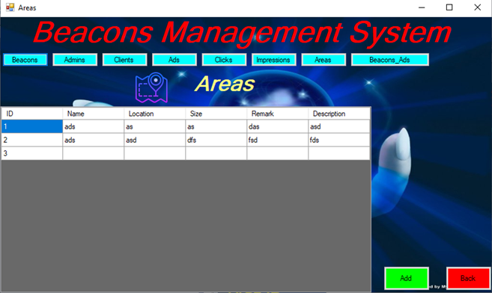

After clicking on the “beacons_ads” button, u can get access to the beacons_ads list. This user control gives you the information about the beacons_ads. It is created using link label and label. Its design is shown below:

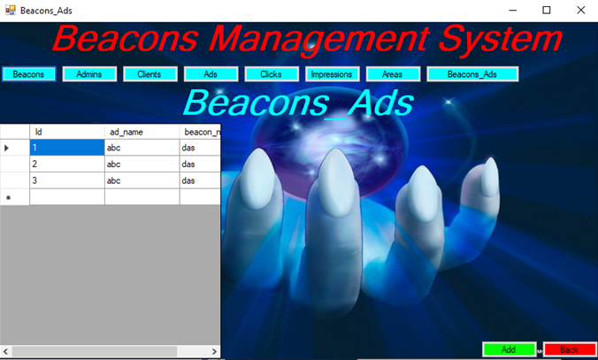

After clicking on the “add” button, u can get access to the add beacons_ads page. This user control helps to insert data .And when you press save botton data will be saved. This user control helps to insert data. It is created using link label and label. Its design is shown below: 

## Beacon Management System

Beacons Management System is a full desktop-based software that uses Microsoft Visual Studio Software to develop. NET Framework technology. The project's main goal is to develop Beacons Management System model software that will contain all data about beacons and advertisements associated with clients.

This software is focused on management and handling of advertisements. The software contains admin, client, ads, beacons, areas, impressions, and clicks related data. This software also presents a well-organized list of information.

## Important features of this application

* This application has a password-protected login type that uses a put away strategy that prevents SQL infusion.
* There are ways for storing, updating, and removing their data.
* The Login username and password are stored in a User form. Additionally, this form helps you to create a new username and password.

## Characteristics of Application

This software displays the data recorded in a system and also able to include new data or, information to the system. The characteristics of each module is given below:

* Login Page: Correct username and password is needed to get access to other modules.
* Add Areas: If we have to expand Area, we could add new Area.
* Add beacons: New beacons could be added with its quality and range.
* Add Clients: New clients could be registered with all the correct information.
* Add ads: Advertisements from different categories could be added and send to the client.
* Add clicks: The amount of clients clicked could be added.
* Add impressions: Number of clients got impressed could be added with the client id.
* All Listing page: Recorded information could be viewed

# Limitations of this Application

A few of the cases are delicate and require different security features, which are a few of the drawbacks of this application. This program may be a software application as restricted to a web application that can be accessed through the web. It is limited to the desktop of a individual computer or a work computer.

# Algorithm and flowchart of application

## **Save Button**

**Algorithm**

Step 1: Start

Step 2: Enter data

Step 3: Validate

Step 4: If true then move to next step 5, if false than return back to Step 1.

Step 5: Save the data

Step 6: Stop

**Flowchart**

MESSAGE BOX

VALIDATE

ENTER DATA

SAVE

FALSE

TRUE

## **Log** **In**

**Algorithm**

Step 1: Start

Step 2: Enter data

Step 3: Validate

Step 4: If true then move to next step 5, if false than return back to Step 1.

Step 5: Save the data

Step 6: Stop

**Flowchart**

ENTER DATA

MESSAGE BOX

VALIDATE

SAVE

# Data flow diagram



An entity relationship diagram (ERD), moreover known as an entity relationship show, could be a graphical representation that portrays relationships among individuals, objects, places, concepts or events inside an data technology (IT) system.

# Feasibility Analysis

This software has been tested for various feasibility criterions from various points of views.

**Economic Feasibility**

The application is anticipated to be financially feasible. The system may be a medium-sized desktop program with a low cost. Increased efficiency, effectiveness, and performance are fair some of the advantages. When the costs and benefits are measured, the application is calculated to be financially viable.

**Technical Feasibility**

Development of the system requires tools like:

• Visual Studio 2015

• .NET Framework 4.5

• Microsoft SQL server 2013, etc

Which are easily available within the estimated cost and schedule?

**Operational Feasibility**

By including the common requirements and necessities, the system offers a better better; a much better; a higher; a stronger; an improved arrangement for libraries. This system's arrangement would be satisfactory as a long-term arrangement for stock management.

**Schedule Feasibility**

The schedule subsection contains an ordered plan for the system's progress. The practical timeline shows that the application implementation can be completed inside the specified time period.

**Recommendation for possible Enhancements:**

* We can include a Stock Report form that appears all the points of interest as well as the whole units remaining of each item.
* We can incorporate a Stock Report shape that appears all the focuses of intrigued as well as the total units remaining of each thing.
* We can set an alarm that rings if the quantity drops to certain threshold to the manager also detailing which quality has reached threshold.
* We can also use wireless tracking of beacons in warehouse with the help of barcode and other tracking criteria.

# Conclusion

I was able to better understand the work stream of this application by utilizing specialized notes, which permitted me to pick up knowledge into how to settle the errors that happened, and I can too utilize it as a direct for potential applications on the off chance that appropriate. I have made user documentation to guarantee that the conclusion user knows how the program works and how to create the most of it.

# References

Anon., n.d. [Online] Available at: <https://www.chanty.com/blog/problem-solving-techniques/>

Anon., n.d. [Online] Available at: <https://study.com/academy/lesson/what-is-an-entity-in-a-database.html>

Anon., n.d. [Online] Available at: <https://study.com/academy/lesson/what-is-an-entity-in-a-database.html>

Anon., n.d. beginnersbook. [Online] Available at: <https://beginnersbook.com/2015/04/e-r-model-in-dbms/>

Anon., n.d. chanty. [Online] Available at: <https://www.chanty.com/blog/problem-solving-techniques/>

Anon., n.d. guru99. [Online] Available at: <https://www.guru99.com/er-diagram-tutorial-dbms.html>

Anon., n.d. hrZone. [Online] Available at: <https://www.hrzone.com/hr-glossary/what-are-motivational-theories>

Anon., n.d. iedunote. [Online] Available at: <https://iedunote.com/maslow-herzberg-theory-comparison>

Anon., n.d. jobs.ac.uk. [Online] Available at: <https://www.jobs.ac.uk/careers-advice/managing-your-career/1318/>

what-is-continuingprofessional-development-cpdAnon., n.d. managementstudyguide. [Online] Available at: <https://managementstudyguide.com/herzbergs-theory-motivation.htm>

Anon., n.d. skillsyouneed. [Online] Available at: <https://www.skillsyouneed.com/ps/continuing-professional-development.html>

Anon., n.d. techtarget. [Online] Available at: <https://searchsqlserver.techtarget.com/definition/database>

Anon., n.d. yourarticlelibrary. [Online] Available at: http://www.yourarticlelibrary.com/motivation/motivation-theories-top-8-theories-ofmotivation-explained/35377

mindtools, n.d. mindtools. [Online] Available at: <https://www.mindtools.com/pages/article/newTMC_00.htm>